**Hands on**

**Workshop Week 6**

**Write a Program:**

1. To count 5 to 15 using PHP loop.

<?php

    for($i = 5;$i<=15;$i++){

       echo "$i<br>";

    }

?>

1. To print “Hello World” using PHP variable.

<?php

   $name = "Hello, World!";

   echo $name;

?>



1. To check student grade based on marks.

<?php

$marks = array(66,70,65,78,91,88);

  $full_total = count($marks)*100;

$total_obtained = array_sum($marks);

$percent = ($total_obtained/$full_total)*100;

if($percent>=70){echo "A grade";}

else if($percent>=60){echo "B grade";}

else if($percent>=50){echo "C grade";}

else if($percent>=40){echo "D grade";}

else{echo "Fail.";}

?>

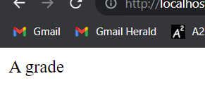

1. To find factorial of a number using loop in PHP

<?php

        function factorial($number){

            $prod = 1;

            for($i = $number;$i>1;$i--){

                $prod*=$i;

            }

            return $prod;

        }

        for($i= 1;$i<10;$i++){

            $f = factorial($i);

            echo "The factorial of $i : $f<br>";

        }

?>

1. 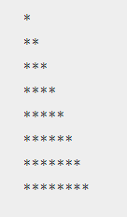To create a given pattern with * using for loop

<?php

        for($i= 1;$i<10;$i++){

            for($j = 0;$j<$i;$j++){

                echo "*";

            }

            echo "<br>";

        }

    ?>

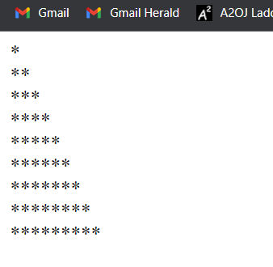

1. $list = array( "Italy"=>"Rome", "Luxembourg"=>"Luxembourg", "Belgium"=> "Brussels", "Denmark"=>"Copenhagen", "Finland"=>"Helsinki", "France" => "Paris", "Slovakia"=>"Bratislava", "Slovenia"=>"Ljubljana", "Germany" => "Berlin", "Greece" => "Athens", "Ireland"=>"Dublin", "Netherlands"=>"Amsterdam", "Portugal"=>"Lisbon", "Spain"=>"Madrid", "Sweden"=>"Stockholm", "United Kingdom"=>"London", "Cyprus"=>"Nicosia", "Lithuania"=>"Vilnius", "Czech Republic"=>"Prague", "Estonia"=>"Tallin", "Hungary"=>"Budapest", "Latvia"=>"Riga", "Malta"=>"Valetta", "Austria" => "Vienna", "Poland"=>"Warsaw") ;

Create a PHP script which displays the capital and country name from the above array $list. Sort the list by the name of the capital.

<?php

$list = array(

    "Italy"=>"Rome", "Luxembourg"=>"Luxembourg",

    "Belgium"=> "Brussels", "Denmark"=>"Copenhagen",

    "Finland"=>"Helsinki", "France" => "Paris",

    "Slovakia"=>"Bratislava", "Slovenia"=>"Ljubljana",

    "Germany" => "Berlin", "Greece" => "Athens",

    "Ireland"=>"Dublin", "Netherlands"=>"Amsterdam",

    "Portugal"=>"Lisbon", "Spain"=>"Madrid",

    "Sweden"=>"Stockholm", "United Kingdom"=>"London",

    "Cyprus"=>"Nicosia", "Lithuania"=>"Vilnius",

    "Czech Republic"=>"Prague", "Estonia"=>"Tallin",

    "Hungary"=>"Budapest", "Latvia"=>"Riga",

    "Malta"=>"Valetta", "Austria" => "Vienna",

    "Poland"=>"Warsaw");

asort($list);// asort() sorts the associative array with value

// after sort, displaying the values

foreach($list as $country => $capital){

    echo "The capital of $country is $capital<br>";

}

?>

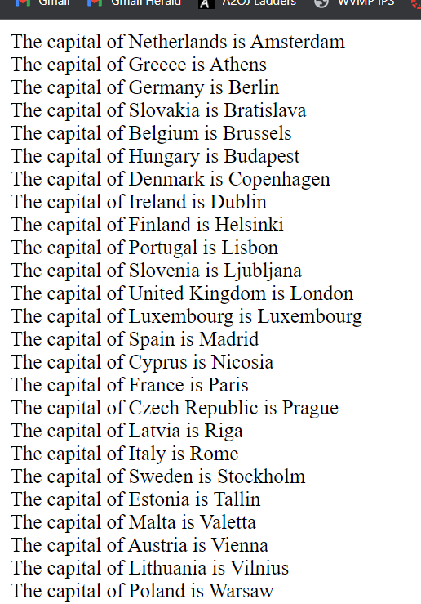

1. Write a PHP function that checks whether a passed string is a palindrome or not?

A palindrome is word, phrase, or sequence that reads the same backward as forward, e.g., madam or dad or noon

<?php

    function palin($string){

        $newString = "";

        for($i = strlen($string)-1;$i>=0;$i--){

            $newString .= $string[$i];

        }

        return $newString==$string;

    }

    $strings = array("madam","dad","laptop");

    foreach($strings as $string){

        if(palin($string)){

            echo "<strong>$string</strong>

            is a palindrome.<br>";

        }

        else{

            echo "<strong>$string</strong>

            is not a palindrome.<br>";

        }

    }

?>

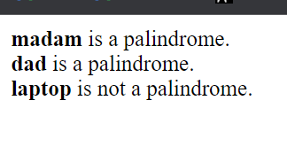

1. To swap two variables

Eg: $a = 1; $b =2; Result: $a = 2; $b=1;

<?php

$a = 1;

$b= 2;

echo "Before swapping, a = $a and b = $b";

//Now swapping the two values

$temp = $a;

$a = $b;

$b = $temp;

echo "After swapping, a = $a and b = $b";

?>

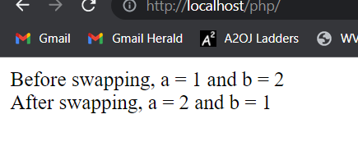

1. To print the multiple of a given number

Example:

define(‘a’,5);

5 10 15 20 25 30 35 40 45 50 use <br> to print in each line

<?php

function print_multiples($value,$terms){

for($i = $value;$i<=($value*$terms);$i+=$value){

echo "$i<br>";

}

}

print_multiples(5,10);

?>

1. To find whether given number is Armstrong or not.

Example:

$number = 153

If ($number == 1*1*1+5*5*5+3*3*3)

Return Armstrong number

Other number: 1, 0, 371, 407 etc

<?php

        function is_armstrong($number){

            $number_string = (string)$number;

            $sum = 0;

            for($i = 0;$i<strlen($number_string);$i++){

                $digit = (int)$number_string[$i];

                $sum+= ($digit*$digit*$digit);

            }

            return $sum==$number;

        }

        $numbers = array(5,7,153,0,407,65);

        foreach($numbers as $num){

            if (is_armstrong($num))

                echo "<b>$num is armstrong</b><br>";

            else

                echo "$num is not armstrong<br>";

        }

    ?>

